ECC Generator Functional Design

Specifications
  - Design and Implementation of CSI Controller IP
  - Version 4.0.1

  - Block Owner
  - Mohamed Zaher Fouda
Authors
Mohamed Zaher Fouda

This Page is left Blank Intentionally

Table of Contents
1 Table of Contents 1
2 Revision History 2
3 Overview 3
4 Operation and Description 3
4.1 Digital Interface 3
4.1.1 Parameters Names 3
4.1.2 Ports Names 3
4.2 Functional Description 3
4.3 Block Diagram 3
4.4 Timing Diagram 3
4.5 Verification Requirements 3

Revision History
Version | Date | Author(s) | Revision Notes | Owner Approval
1 | 20-11-2025 | Mohamed Zaher Fouda
3 Overview The ECC (Error Correction Code) Generator is a crucial sub-block within the MIPI CSI-2 TX Controller. It is responsible for computing the 6-bit Hamming code used to protect the 24-bit Packet Header (PH) of the Low Level Protocol (LLP) packets. Its primary function is to take the 8-bit Data Identifier (DI) and the 16-bit Word Count (WC) from the FSM Controller, calculate the corresponding SEC-DED (Single Error Correction, Double Error Detection) checksum, and append it as the final byte of the 32-bit Packet Header. This ensures that the receiver can detect and correct single-bit errors or detect multi-bit errors in the critical header information.
4 Operation and Description 4.1 Digital Interface 4.1.1 Ports Names
Port Name | Port Width | Port Type | Description
Clocks & Resets
i_byte_clk | 1 | Input | High-speed Byte Clock.
i_rst_n | 1 | Input | Active-low Asynchronous Reset.
Upstream Interface
i_di | 8 | Input | Data Identifier (Virtual Channel + Data Type).
i_wc | 16 | Input | Word Count payload for the current packet.
i_calc_req | 1 | Input | Request trigger from FSM to compute ECC.
Downstream Interface
o_ecc_out | 8 | Output | Computed 8-bit ECC value (6 bits active, 2 MSBs are 0).
o_ecc_valid | 1 | Output | Valid flag asserting that computation is complete.
4.2 Functional Description The architecture of the ECC Generator is purely combinational, utilizing an optimized XOR tree network to ensure zero-cycle latency computation, fitting seamlessly into the Packetizer's header generation phase.
- Input Concatenation: Role: The module first concatenates the 24-bit header data by combining i_di[7:0] and i_wc[15:0] into a single 24-bit vector.
- XOR Tree Calculation:
  - Role: Implements the standard MIPI CSI-2 Hamming code matrix.
  - Operation: Six independent parallel XOR equations are evaluated against specific bit positions of the 24-bit header.
  - Bits 0 through 5 of the ECC are generated concurrently using these equations to ensure SEC-DED compliance.
- Padding and Output:
  - Role: Formats the calculated code into a standard byte for transmission.
  - Operation: The computed 6-bit code is assigned to o_ecc_out[5:0]. The two Most Significant Bits, o_ecc_out[7:6], are permanently tied to 2'b00 as mandated by the MIPI protocol. The output is held valid (o_ecc_valid) in the same cycle the i_calc_req is asserted.
4.3 Block Diagram
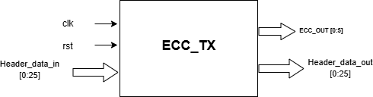
Figure 1 ECC Generator Block Diagram

4.4 Timing Diagram
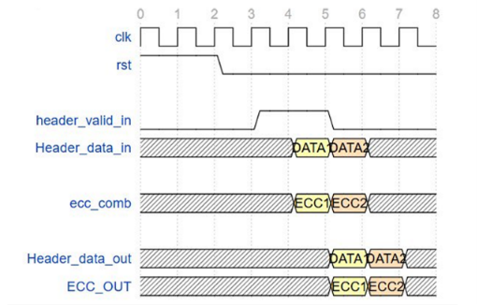
Figure 2 ECC Generator Block Diagram
4.5 Verification Requirements
- Mathematical Accuracy: Verify that the generated 6-bit code perfectly matches the expected MIPI CSI-2 standard Hamming polynomial across exhaustive test vectors for all 24-bit input combinations.
- Padding Verification: Ensure that the upper 2 bits of the output byte (o_ecc_out[7:6]) are strictly driven to 0 under all conditions.
- Latency and Glitch Checking: Verify that the combinational XOR tree does not violate setup times for the downstream Packetizer FSM, ensuring the ECC is ready for the 4th byte of the Header transmission without stalling the pipeline.

